|  |  |  |  |  |
| --- | --- | --- | --- | --- |
| Module 1 Workshop Attendance | | | | |
| Group No: | | | | |
| s | s | s | s | s |
| s | s | s | s | s |

* For each risk, assess the likelihood of the loss or damage occurring – “almost certain,” “likely,” “moderate,” “unlikely” and “rare” (consecutive points 5, 4, 3, 2, 1)
* For each risk, identify the consequences of loss or damage occurs as a result of the risk being taken. Rank the seriousness of each consequence – “extreme,” “major,” “moderate,” “minor” and “negligible” (consecutive points 5, 4, 3, 2, 1)
* Assess the level of each risk. [Risk level = Likelihood x seriousness of consequence]

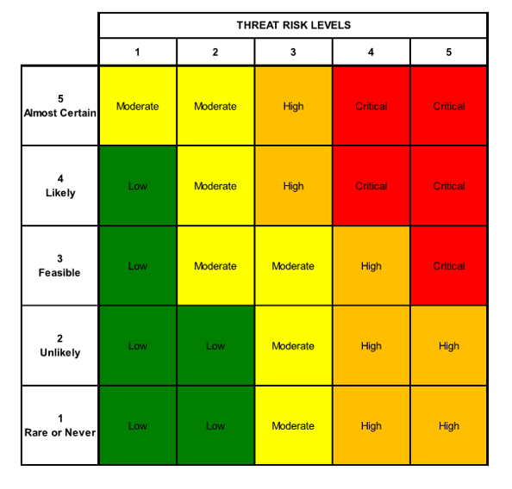

* Transfer risk techniques: Contracting, Retention, Bonding, Insurance, Contingency.
* Transfer risk techniques: Avoid, Transfer, Mitigate, Accept

**NAME OF THE PROJECT:**

PROJECT OBJE CTIVES: COST, TIME, QUALITY, SAFETY & ENVIRONMENT

|  |  |  |  |  |  |
| --- | --- | --- | --- | --- | --- |
| Risks at Feasibility Stage | | | | | |
| 1 |  | **Likelihood** | **Consequences** | **Risk level** | **Treatment** |
| 2 |  |  |  |  |  |
| 3 |  |  |  |  |  |
| 4 |  |  |  |  |  |
| 5 |  |  |  |  |  |
| 6 |  |  |  |  |  |
| 7 |  |  |  |  |  |
| 8 |  |  |  |  |  |
| Risks at the Design Stage | | | | | |
| 1 |  |  |  |  |  |
| 2 |  |  |  |  |  |
| 3 |  |  |  |  |  |
| 4 |  |  |  |  |  |
| 5 |  |  |  |  |  |
| 6 |  |  |  |  |  |
| 7 |  |  |  |  |  |
| 8 |  |  |  |  |  |
| 9 |  |  |  |  |  |
| 10 |  |  |  |  |  |
| Risks at the Construction Stage | | | | | |
| 1 |  |  |  |  |  |
| 2 |  |  |  |  |  |
| 3 |  |  |  |  |  |
| 4 |  |  |  |  |  |
| 5 |  |  |  |  |  |
| 6 |  |  |  |  |  |
| 7 |  |  |  |  |  |
| 8 |  |  |  |  |  |
| 9 |  |  |  |  |  |
| 10 |  |  |  |  |  |
| Risks at the Operation Stage | | | | | |
| 1 |  |  |  |  |  |
| 2 |  |  |  |  |  |
| 3 |  |  |  |  |  |
| 4 |  |  |  |  |  |
| 5 |  |  |  |  |  |
| 6 |  |  |  |  |  |
| 7 |  |  |  |  |  |